A000- PAC-POLY-Nukuoro-Outrigger-Breadfruit Wood-Pandanus-20th c

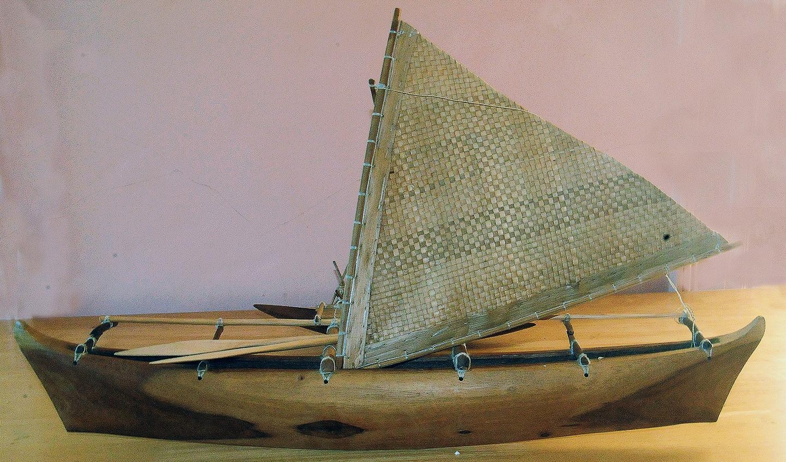

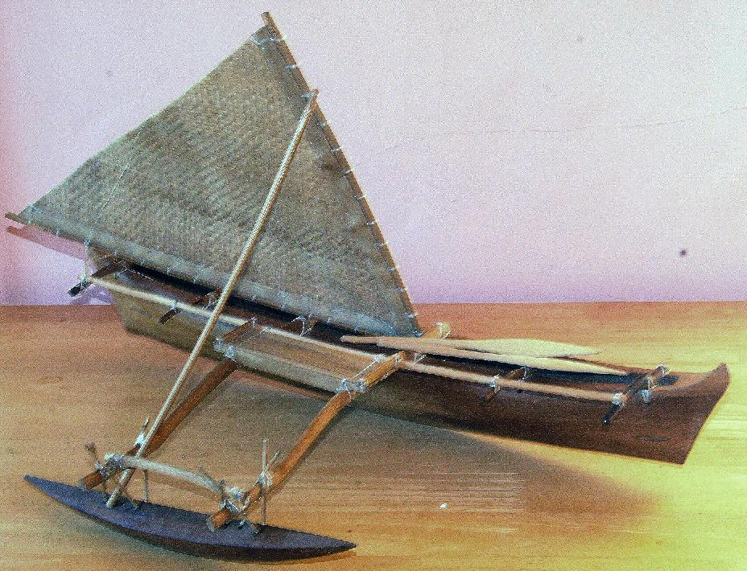

PAC-POLY-Nukuoro-Outrigger-Breadfruit Wood-Pandanus-20th c

Case No.: Oceania

**Accession No.**

**Formal Label:** PAC-POLY-Nukuoro-Outrigger-Breadfruit Wood-Pandanus-20th c

**Display Description:**

The sail is the typical Micronesian woven reed triangular lateen sail. The sail must always be windward of the single outrigger float, since the wind in the sail cannot easily lift the float out of the water. If it were mounted to leeward, the wind could easily capsize the boat. This type of outrigger canoe is sometimes called a shunting canoe, since it sails equally well in either direction, but cannot come about like a modern yacht with a Bermudian or Marconirig, a configuration of mast and rigging.

This type of canoe originated in Polynesia and was adapted Nukuoroan settlers. These double-ended, single-masted outrigger canoes (*paopao*) had elegantly shaped dugout hulls, with a bottom convexly curved longitudinally and an angular forefoot at bow and stern. They were fitted with two booms (*kiato*) each connected to a fairly stout float (*te ama*) by two pairs, an outer and an inner, of stanchions (*atoto*) and a bipartite cord brace (*soa soa*). These elements are arranged in a manner related to the foreboom attachment of Tahitian canoes (Haddon and Hornell 1991 1:395-397). Since they skimmed across vast miles of ocean so efficiently, they were popularly called “flying proas” by European sailors and settlers in the early 20th century. Micronesia is a water-world of thousands of scattered small islands, atolls and archipelagos where the traditional arts of sailing and navigating outrigger canoes survived into the modern era.

**LC Classification:**

**Date or Time Horizon:**

**Geographical Area:**

**Map:**

**GPS coordinates:**

**Cultural Affiliation:**

**Media:**

**Dimensions:** 26" lon

**Weight:**

**Condition:**

**Provenance:**

**Discussion:**

Nukuoro Atoll (Ponape District, Trust Territory of the Pacific Islands) is a nearly circular atoll with a deep central lagoon and a fringing reef with forty-six small islets or *modu* (cf. Hawai’ian *motu*) that extend from the northwest clockwise to the southwest, which at low tide are interconnected.

This type of canoe originated in Polynesia and was adapted Nukuoroan settlers. These double-ended, single-masted outrigger canoes (*paopao*) had elegantly shaped dugout hulls, with a bottom convexly curved longitudinally and an angular forefoot at bow and stern. They were fitted with two booms (*kiato*) each connected to a fairly stout float (*te ama*) by two pairs, an outer and an inner, of stanchions (*atoto*) and a bipartite cord brace (*soa soa*). These elements are arranged in a manner related to the foreboom attachment of Tahitian canoes (Haddon and Hornell 1991 1:395-397). Since they skimmed across vast miles of ocean so efficiently, they were popularly called “flying proas” by European sailors and settlers in the early 20th century. Micronesia is a water-world of thousands of scattered small islands, atolls and archipelagos where the traditional arts of sailing and navigating outrigger canoes survived into the modern era.

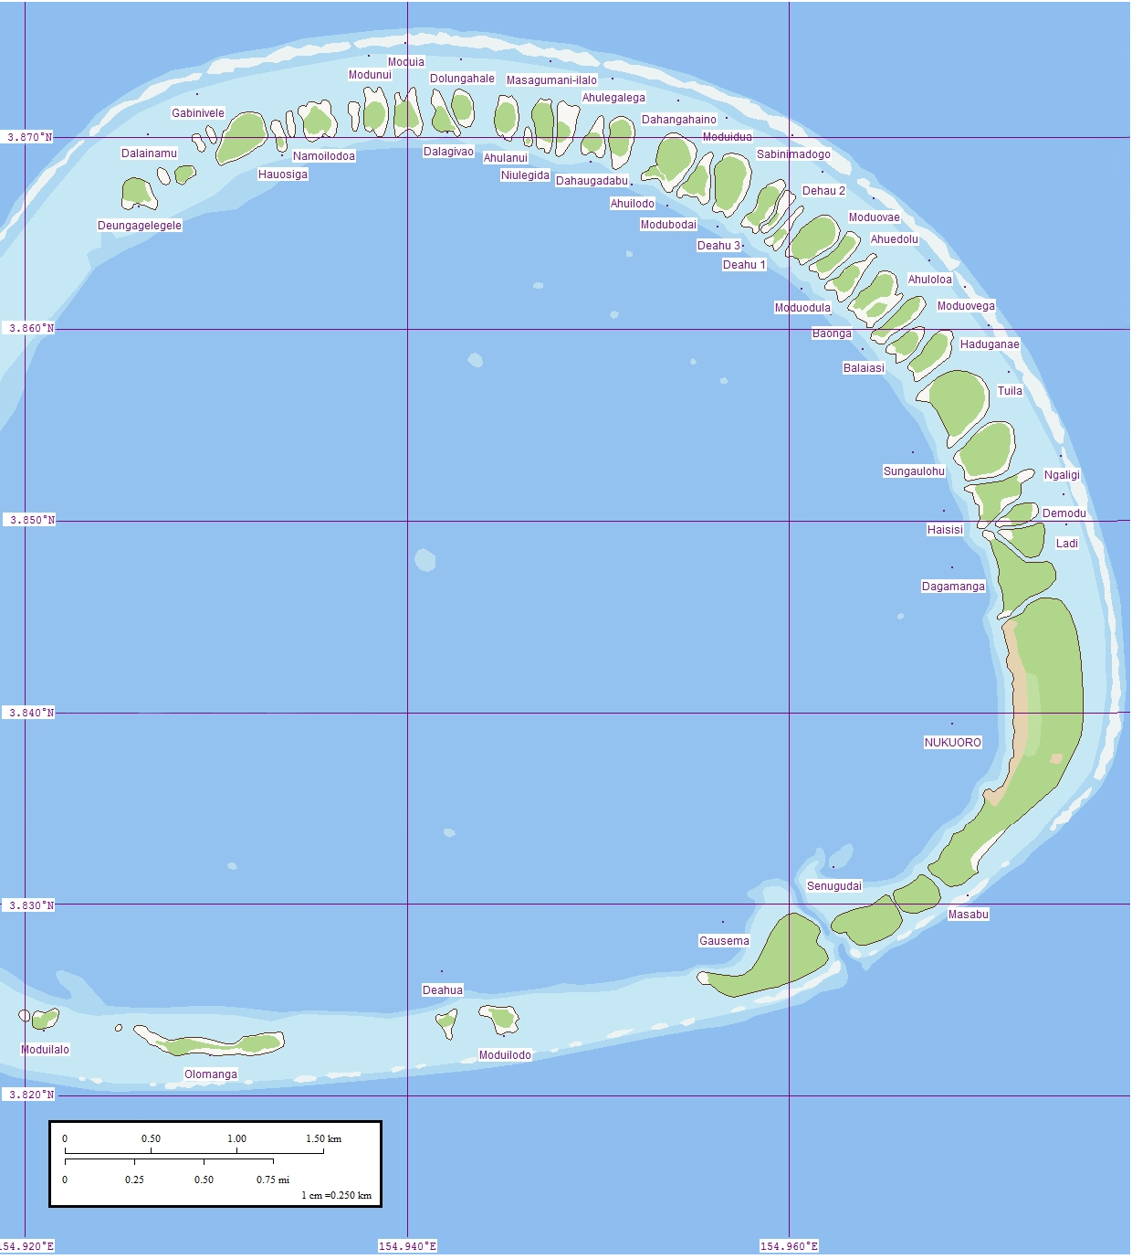

Fig. 1. Nukuoro Atoll, Caroline Islands, Micronesia. Map of eastern rim that contains forty-six small islets or *modu*.

Nukuoro atoll was settled in the eighth century AD/CE, by Samoan migrants who voyaged in two canoes under chief Wawe, landed at Nukufetau in Tuvalu and then set sail for the uninhabited *modu* of Nukuoro atoll in Micronesia. The settlement of a Micronesian atoll by Polynesians created a “Polynesian outlier”. The eighth century is important climatologically and socially, since favorable weather conditions during the seventh century had induced increasing populations on many Pacific islands making the incentive to migrate attractive to many as internecine strife ensued with the stresses of increasing populations. These Nukuoro immigrants brought their Polynesian language, concepts of social hierarchy, genealogy, and an aesthetic acumen that would inform the basis of a totally unique style of human figuration in banana-fruit wood as in the current example. In addition, these Polynesians also incorporated Micronesian principles from Tuvalu such as outrigger canoe construction that was useful in an isolated atoll (as in the current outrigger canoe model) and banana-fiber loom weaving which proved suitable for canoe sails (as in the current outrigger canoe model) as well as clothing for themselves and for adorning figures of their deities.

Nukuoro was first contacted by western Europeans when the Spanish Captain Juan Bautista Monteverde of the frigate Pala on 18 February 1806 en route from Manila to Lima, Peru named Nukuoro "Dunkin Is." and noted that the natives who came out to trade "are of the most pacific disposition" (Hezel 1979, Sharp 1960: 189, Ward 1967).

## References

## De Grunne, B. 1994. “Beauty in Abstraction: the Barbier-Mueller Nukuoro Statue”. *Art Tribal*, Geneva: 25-40.

## Doane, E.T. 1874. The Caroline Islands (Cruise of the Star). The *Geographical Magazi*ne, 1:203-205.

## D’Urville , M.J. Dumont. 1843. *Voyage au Pole Sud et dans L’Oceanie sur les Corvettes L’Astrolabe et la Zelee*. Vol. V. Paris, Gide et Cie.

## Eilers, A. 1934. “Inseln um Ponape”. *Ergebnisse der Sudsee-Expedition 1908–1910*. IIB Vol. 8. Hamburg, Friederichsen de Gruyter.

## Hezel, Fr. Francis X. S.J. 1979. http://www.micsem.org/pubs/articles/historical/forships/pohnpei.htm .

Kaeppler, Adrienne L. 2008. The Pacific Arts of Polynesia & Micronesia .Oxford: Oxford University Press.

Kaufmann, Christian, Oliver Wick (eds.). 2013. Nukuoro. Sculptures from Micronesia. Basel: Fondation Beyeler, Hirmer.

## Kubary, J. 1900. “Beitrag sur Kenntnis der Nukuoro- oder Monteverde Inseln”. *Mitteilungen der Geographischen Gesellschaft in Hamburg*, XVI.

## Morrell, Benjamin. 1832. **A Narrative of Four Voyages to the South Sea, North and South Pacific " Ocean, Chinese Sea, Ethiopic and Southern At/antic Ocean, Indian and Antarctic Ocean, from the Year 1822 to 1831**. New York, J. & J. Harper.

Sharp, Andrew. 1960: The Discovery of the Pacific Islands. Oxford: Clarendon Press.

## Volprecht, K. 1968. “Nukuoro: Zur Sammlung Kapitan Jesche im Rautenstrauch-Joest-Museum.” *Ethnologica* (NF) Band 4: 532-542.

Ward, R. Gerard, ed. 1967. American Activities in the Central Pacific 1790-1870.8 Vols. Ridgewood, NJ, The Gregg Press.